DROP TRIGGER cashierShiftTrigger ON cashier;

CREATE OR REPLACE FUNCTION add_shift() RETURNS TRIGGER AS $$

DECLARE

curs CURSOR FOR SELECT * FROM cashier;

new_shift cashier%ROWTYPE;

BEGIN

IF OLD.shift > 4 THEN

FOR new_shift in curs LOOP

UPDATE cashier SET shift = new_shift.shift + 1 WHERE CURRENT OF curs;

END LOOP;

RAISE NOTICE 'Success';

RETURN NEW;

ELSE

RAISE NOTICE 'Fail';

RETURN OLD;

END IF;

END;

$$ LANGUAGE plpgsql;

CREATE TRIGGER cashierShiftTrigger

BEFORE DELETE ON "cashier"

FOR EACH ROW

EXECUTE PROCEDURE add_shift()

Info before trigger call

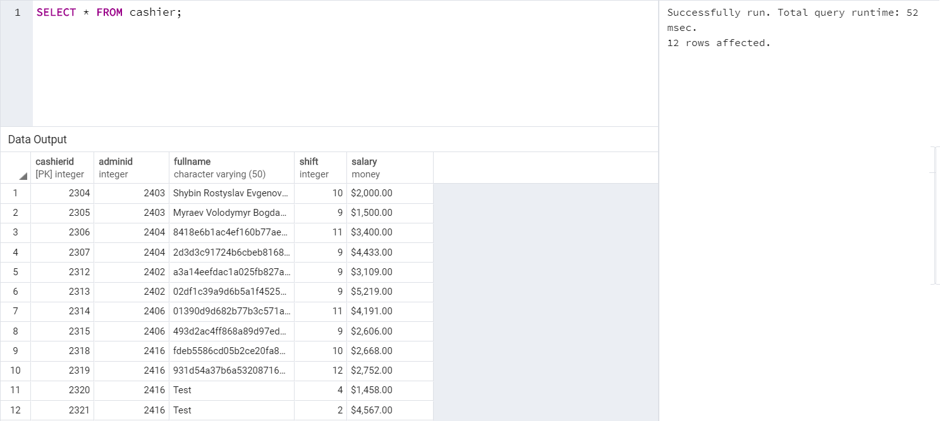

Correct condition



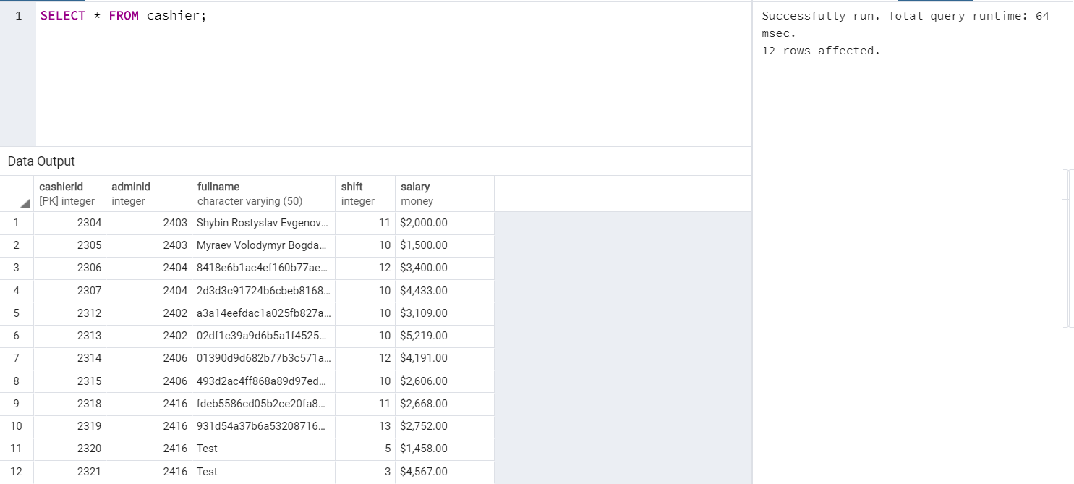

Incorrect condition



